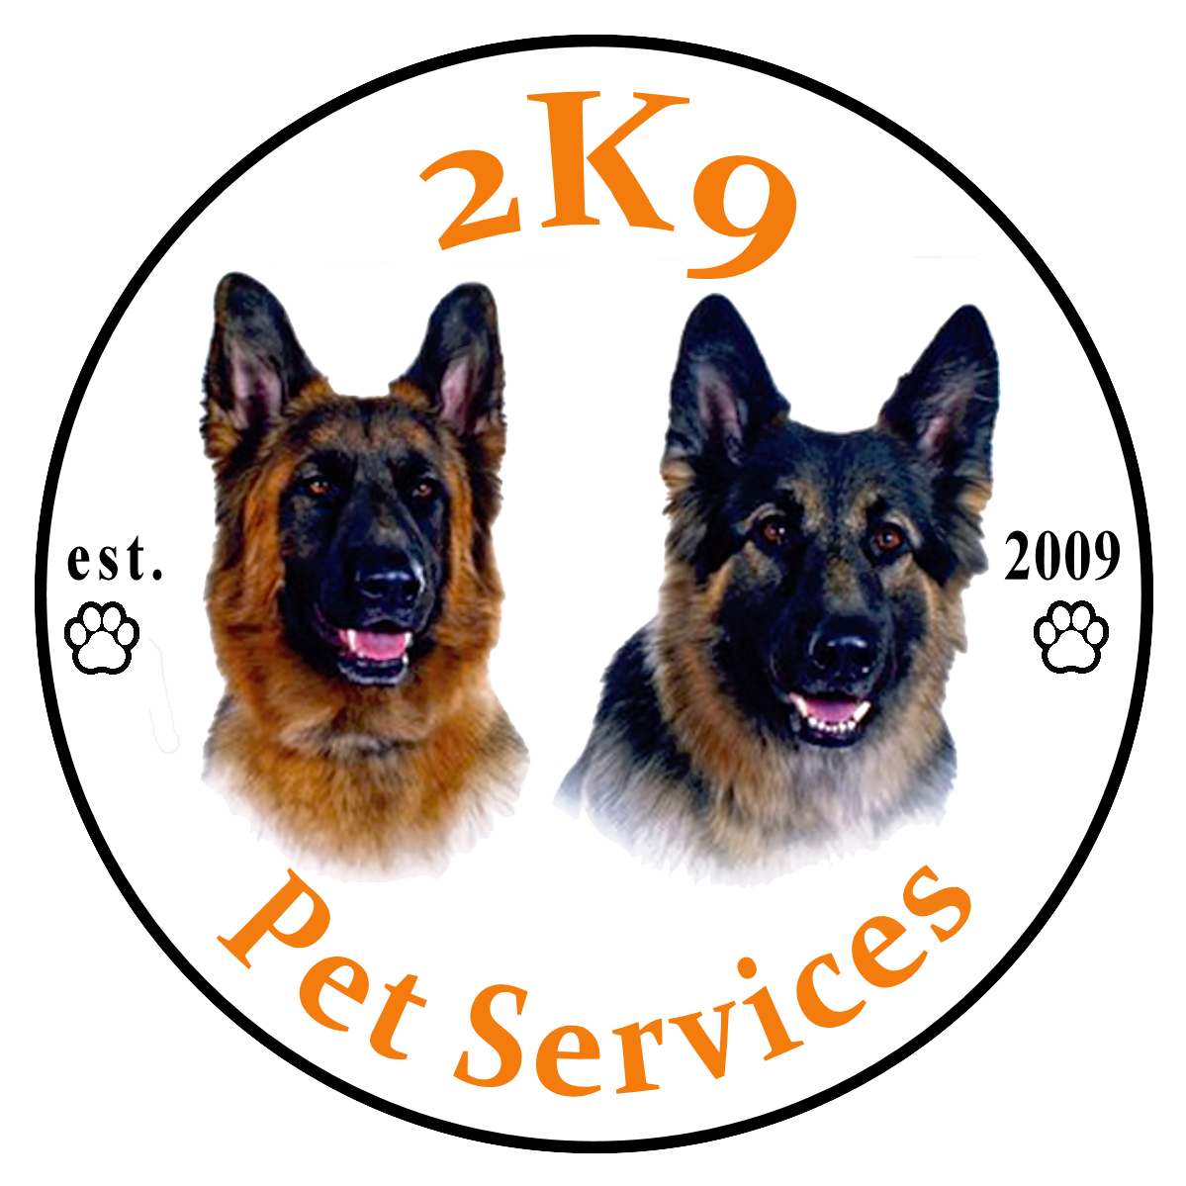
Terms and Conditions of 2K9 Pet Services Ltd

The contract between 2K9 Pet Services Ltd will last for the duration of services used. The medical history of your dog will need to be updated as soon as practicable so 2K9 Pet Services Ltd can keep the welfare of your and other client’s dogs at the highest possible standard.

1: All clients who use any service provided by 2K9 Pet Services Ltd will be deemed to have read, understood and agreed to each of these Terms and Conditions, as laid out here, on signature or by using any service. A copy of the Terms and Conditions will be provided to all clients, or where needed, available to be read prior to the use of any service.

1.1: The client agrees to provide full and honest information to 2K9 Pet Services Ltd about their pets during the booking procedures. Behaviours which may negatively impact on myself, any person related to 2K9 Pet Services Ltd or others dogs that are under the care of 2K9 Pet Services Ltd, will not be accepted. These include but are not limited to: excessive barking or anti-social behaviour, aggression towards any humans or pets, separation anxiety, destructive behaviour, consistent straying and any phobias where the dog is reactive.

1.2: Should a client wish to change the days their dog/s are cared for on their contract, 2K9 Pet Services Ltd must be notified 2 weeks in advance, a new contract form will be provided and need to be signed by the client and 2K9 Pet Services Ltd before the change is confirmed.

1.3: 2K9 Pet Services Ltd will not confirm any booking until a full consultation has been carried out with the client, dog/s and the contract, the Terms and Conditions and all necessary forms have been agreed to and signed by all parties where needed.

1.4: Clients agree to an introductory meeting held at the client’s home, allowing 2K9 Pet Services Ltd to meet the dog/s to discuss all aspects of care needed and an outside meeting in a neutral area may be arranged before acceptance of the dogs is confirmed.

1.5: All dogs being walked will undergo a trial period (length depends on regularity) to ensure that they are adequately trained, socialised and suitable to join other client’s dogs.

1.6: By law, the client must provide a lead & collar with pet ID tags on. A towel for drying is to be left in bad weathers for 2K9 Pet Services Ltd to wipe down your dog….
Please note: for safety reasons extendable leads, prong/pinch or e-collars will not be accepted. 2K9 Pet Services Ltd reserves the right to terminate any contract with immediate effect should prong collar and/or an e-collar be used by the client.

1.7: The duration of a walk will be 50 minutes. This will give 2K9 Pet Services time Ltd time to wipe down any dogs that are dirty before being returned and any elderly, juvenile or dogs with any underlying health conditions won’t be over exercised. 2K9 Pet Services Ltd also advises that dogs do not eat food for at least an hour before or after their walk, as serious health implications may occur.

2: The client must provide 2K9 Pet Services Ltd with the name and contact number of someone capable of making a decision relating to the pet(s) in an emergency. If they are unavailable at time of contact (2 attempts), 2K9 Pet Services Ltd reserves the right to consult with a veterinary surgeon and then make a decision (in the opinion of 2K9 Pet Services Ltd) that is in the best interests of the animal.

2.1: The emergency contact will be asked to take over care for the dog/s in the event of an emergency or if your dog displays behaviour towards humans and other dogs which meant they can no longer be cared for if the owner cannot be reached.
The types of behaviours can be found in above in Number 1.

2.2: The client agrees that if their pet attacks another animal, person or any representative of 2K9 Pet Services Ltd and this results in injury to that animal or person, they will be responsible for any expense incurred and a contribution towards any loss of earnings as a result, where gross negligence did not occur. This includes payment of veterinary fees incurred as a result of injuries to another animal caused by their dog. The dog will be removed with immediate effect and placed with the emergency contact (if owner is not reachable) who will collect the dog/s as soon as possible and no refund to the owner will be due. Should the owner and/or emergency contact not be readily available, 2K9 Pet Services Ltd shall contact a nearby kennel to temporarily hold them until they can be picked up. The client will be liable for any charges due to kennelling for reasons described above.

3: Full payment for services (agreed either at time of booking or subsequently) is to be paid on Monday, or your first day, for the week ahead via cash or bank transfer.
Please note: If payment has not been received, 2.5% of the total amount outstanding will be added for each day that payment is overdue and your dog/s will not be walked for as long as payment has not been received.

3.1: The client is responsible for adjusting their weekly payment to take any Bank Holidays into consideration.

4: The client agrees that they will be handing over their dog/s to 2K9 Pet Services Ltd in good health. Any injuries, illnesses or ailments, must be disclosed prior to commencement of any service provided by 2K9 Pet Services Ltd and any medication will be supplied and detailed on the Medication Permission Form. If any illness appears or has not been disclosed upon pick up or drop off and appears to be or is diagnosed as contagious or the health of the dog/s may be affected, the client or if not available, the emergency contact will be asked to collect the dog/s immediately unless veterinary attention is needed immediately. No refund will be given in this circumstance.

4.1 A dog can only be returned to 2K9 Pet Services Ltd once their Vet has clarified the illness as no threat to myself, any other dog/s and any injury will not impair on their daily health. This must be in writing from your vet with their letterhead and signed. Confirmation may be sort in certain cases and 2K9 Pet Services Ltd reserves the right to contact your Vet to check. Emails from your vet are accepted.

4.2: At any time, once a service has started, should your dog/s have any new behavioural problems, illness, infection or injury, however minor, 2K9 Pet Services Ltd MUST be informed immediately. The relevant form will need to be updated, for the health, welfare and control of possible disease to your own dog/s, other dog/s and to maximise infection control within any vehicle owned by 2K9 Pet Services Ltd. Failure to inform 2K9 Pet Services Ltd of such issues, may result in suspension of your dog/s routine until a veterinarian signed letter saying your dog/s is of good health to resume their routine and has been received by 2K9 Pet Services Ltd.
Please note: charges may apply for any days your dog/s are not walked where 2K9 Pet Services Ltd has not been informed.

5: The client will inform their veterinarian that 2K9 Pet Services Ltd will be caring for their pets (for which ever days is agreed to in the contract) and if possible arrange for card details to be held, so that emergency payments can be made in the event of veterinary attention. Any veterinary fees that are incurred for your pets and have been paid by 2K9 Pet Services Ltd (as a good will gesture to the vets), must be reimbursed immediately on your return. A daily charge of 10% will be added to the outstanding amount until full payment has been received.

6: Your dog(s) medical history and treatment must be made available in the event of….
illness, or injury and cannot return until I have advice from the vet that the dog is of adequate health to do so.

6.1: If a medical emergency arises for the dog(s), 2K9 Pet Services Ltd will make every effort to inform the emergency contact. Where time is of the essence, the client authorises 2K9 Pet Services Ltd to seek medical services at the nearest veterinary practice. The client agrees to reimburse for all services rendered by a veterinarian and/or any payments made by 2K9 Pet Services Ltd in accordance with the owners wishes as stated and signed in the veterinary release form.

6.2: The client must provide 2K9 Pet Services Ltd with the name and contact number of someone capable of making a decision relating to the pet(s) in an emergency. If they are unavailable at time of contact (2 attempts), 2K9 Pet Services Ltd reserves the right to consult with a veterinary surgeon and then make a decision (in the opinion of 2K9 Pet Services Ltd) that is in the best interests of the animal.

7: In the event of serious accident, injury or illness to myself, the client accepts that alternative emergency cover will be arranged for their dog(s). This will be done with the involvement of the client’s emergency contact(s) wherever possible. Temporary cover may be arranged for client’s who require it and only a trusted, insured and competent person will be chosen by 2K9 Pet Services Ltd.

8: 2K9 Pet Services Ltd takes their role very seriously and will care for the client’s dog/s to the best of their ability. Unless otherwise agreed, your dog(s) will be exercised as per their usual equipment used. Where a client is happy that their dog is allowed to run free off the lead, they must be willing to sign an off-lead form, under which the client agrees to accept responsibility for accident, injury or loss, caused by or to their dog as long as it can be proved 2K9 Pet Services Ltd have not acted in a negligent manner. If their usual equipment is not readily available, 2K9 Pet Services Ltd will not search your property for it and will therefore not be able to take your dog(s) out for that day. No refund or in lieu payment will be given should this occur.

9: All dogs must provide proof of protection against the core disease (kennel cough is NOT compulsory when using 2K9 Pet Services Ltd). If needed, they must also be wormed and treated for flees/tics before being placed in the care of 2K9 Pet Services Ltd and this is the client’s responsibility. If you, the client, do vaccinate yearly, all vaccinations or course of vaccinations MUST be accompanied by proof before a contract can be signed and started. 2K9 Pet Services Ltd reserves the right to decline any animal that is showing symptoms of such diseases. Vaccicheck/Titre test are acceptable with proof of results provided prior to commencement of any service.

9.1: If external parasites are present on the client’s dog/s, 2K9 Pet Services Ltd may refuse to take them out until the parasites no longer exist and proof of preventatives has been administered.

10: 2K9 Pet Services Ltd will carry out all agreed services in a reliable, caring and trustworthy manner. In consideration of these services and as an expressed condition thereof, the client waives and relinquishes any and all claims against 2K9 Pet Services Ltd, except those arising from gross negligence or misconduct of 2K9 Pet Services Ltd.

11: The client authorises the signed contract to be valid approval for future services, therefore allowing 2K9 Pet Services Ltd to accept future bookings without additional signed contract or authorisation.

12: Although 2K9 Pet Services Ltd holds Public Liability Insurance, where ever possible, pets should be insured by the client. 2K9 Pet Services Ltd reserves the right to refuse a booking for any animal that is not insured.

13: 2K9 Pet Services Ltd must receive the client’s cancellation at least 48 hours before their walk. If the required notice is not given a 50% charge will apply. Should 2K9 Pet Services Ltd cancel a service, there is no charge.

14: As you, the client, have provided a key to your property for the use of either 2K9 Pet Services Ltd, or when the client is informed, a trusted handler who has the relevant insurance, no liability will be held for any loss, damage to or any other circumstance to your property if any other person has access (a key) during the term of the contract. 2K9 Pet Services Ltd must adhere to their insurance policy and will always make sure any door opened, is closed and left secure upon entrance and exit of your property.

14.1: If you have any home security cameras or key code entry systems, it is your responsibility to inform 2K9 Pet Services Ltd of their existence, location and entry codes. 2K9 Pet Services Ltd, by the GDPR law, cannot and will not reveal any information given to them by the owner to outside companies or 3rd party people unless previously agreed with the client.

15: Contract breaks - 2K9 Pet Services Ltd cannot guarantee the clients slot whilst you are away on holiday, have a bitch in season, during school holidays or any other break (longer than 1 week) that may be needed….
2K9 Pet Services Ltd requires a 25% retainer of your normal weekly rate up to a maximum of 4 weeks, to guarantee the client’s slot is kept open. If the client is planning a break of longer than 4 weeks and wishes to keep their slot, 2K9 Pet Services Ltd will discuss the situation with the client. Failure to adhere to the retainer fee may result in your slot not being kept open for when you wish to return. The fee will still be owed and must be paid, further action may occur.

16: 2K9 Pet Services Ltd will apply personal judgement and cut short a walk if necessary because of extreme weather conditions (heat, thunderstorms, snow or gales), for the safety of both the dog/s and the walker.

16.1: All new dogs will be exercised on a lead at the discretion of 2K9 Pet Services Ltd for a period that is necessary until the dog/s are responsive to the handler. Longer training lines are used to allow dogs to have more freedom but still be under control from the handler and will only be removed once 2K9 Pet Services Ltd is satisfied the dog can behave off lead.

16.2: If a dog does not behave to the high standards 2K9 Pet Services Ltd expects, any and all dogs will be placed back on lead for as long as deemed necessary before allowing them off lead exercise. This also includes for the dogs safety.

17: Please be aware that 2K9 Pet Services Ltd are unable to accept female dog/s when in season. It is for the welfare of the dog/s not to be walked as their normal routine will be different, the risk of mating and/or affecting male dog/s in the area will be greatly increased.

17.1: If 2K9 Pet Services Ltd is not informed, 2K9 Pet Services Ltd will charge full price for the first day and 50% of the second. The dog must be fully out of season and have had a bath/groom to remove any smell that may attract any unwanted attention from other dog/s and to minimise any stress of your dog/s.

18: Epidemic or Pandemic. If there is one of the aforementioned and you, the client, are experiencing any related symptoms or feel unwell but not related, MUST inform 2K9 Pet Services Ltd as soon as practicable. Failure to may result in suspension and/or charges.

19: Clients wishing to terminate their contract and all services provided by 2K9 Pet Services Ltd, must give a minimum of 2 weeks’ notice. Failing this, full payment for both weeks will still be charged which will include any late payment charges. This must be done via email or written letter, any other forms of communication will not be accepted, such as social media, text message or phone call, these will be taken as your intension and not as a notification.

19.1: 2K9 Pet Services Ltd reserves the right to cancel the contract of any client or service being used, at any time and if needed, with immediate effect if the dog does not respond well to the walker and/or other dogs, or for any other reason which will be discussed with the client. Also, if there is an attack on a human and/or other animal that requires immediate emergency hospitalisation or veterinary care.
20: 2K9 Pet Services Ltd makes every effort to minimise soiling of any vehicle owned by 2K9 Pet Services Ltd. However please be aware that should a client’s dog/s be sick, urinate, defecate or damage any vehicle or equipment owned by Simon Reed for the use of 2K9 Pet Services Ltd, the client will be notified and a minimum of £20 will apply. If there is more, the client will be given notice of the total and if needed, a payment arrangement can be made. For dogs who may repeatedly damage or soil the vehicle, 2K9 Pet Services Ltd will talk with the client to try and stop it happening again.

21: 2K9 Pet Services Ltd reserves the right to amend or add to their Terms and Conditions without prior notice, but will provide the client will a new copy if they do indeed change, to which the client will be deemed to have accepted.

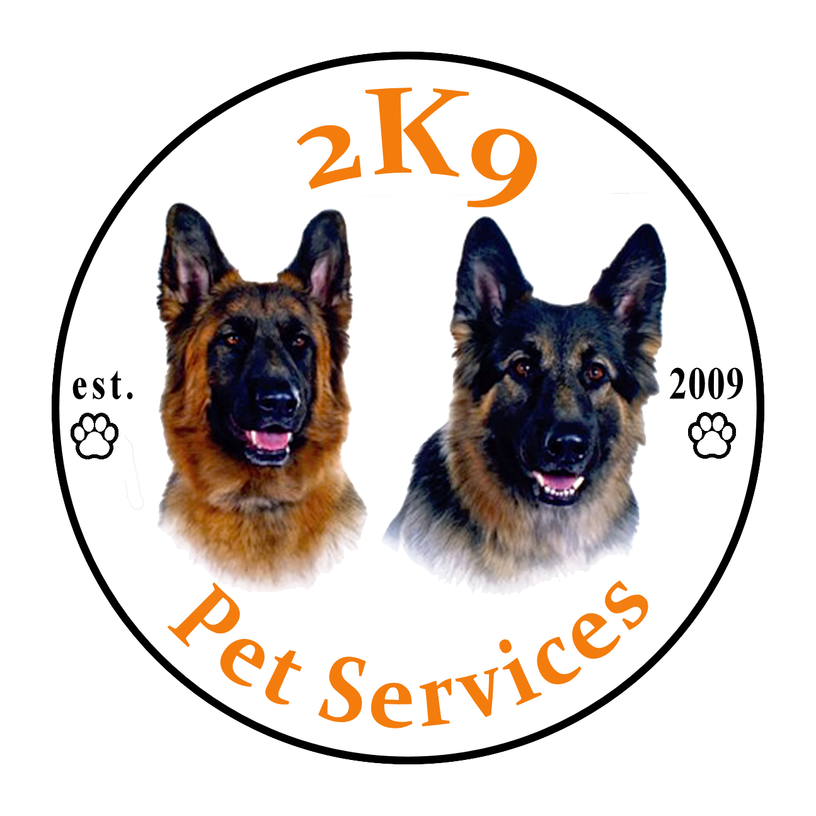

I, the undersigned, have read, understood and agree to the Terms and Conditions above upon using the services of 2K9 Pet Services Ltd. I understand that any outstanding fee will be paid promptly to avoid additional fees being added. I confirm that I will be responsible for any costs however they are incurred, either veterinary or other, as a result of any health issue, accident or damage caused by my pet, accepting 3rd party liability, and that I will pay such costs upon return unless caused by gross negligence by 2K9 Pet Services Ltd. By signing these forms, I am agreeing to follow through with this booking, pay any fees due and entering into the contract.

I/We have read through this information and accept the Terms and Conditions within. (please tick)

Client’s printed name: __________________________________________________

Client’s signature: _______________________________________________

Date: ___________________

Walker’s printed name: __________________________________________________
(On behalf of 2K9 Pet Services Ltd)

Walker’s signature: __________________________________________________
(On behalf of 2K9 Pet Services Ltd)

Date: ___________________

